Common Eastern Froglet  (Crinia signifera)  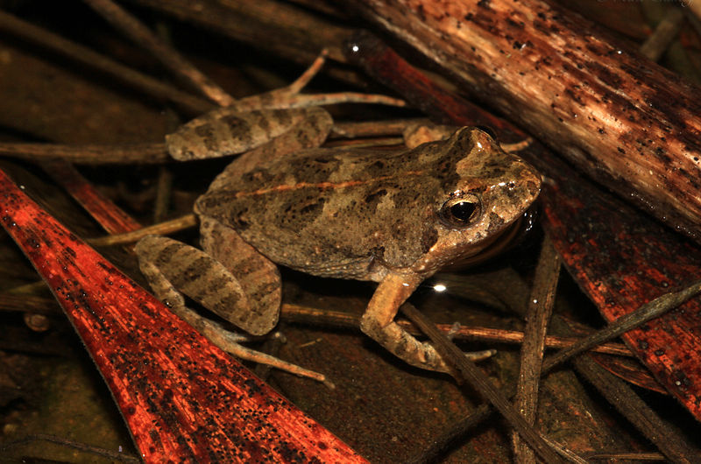  Common Froglet CC –BY Matt (2013) | Green Tree Frog  ( Litoria caerulea)  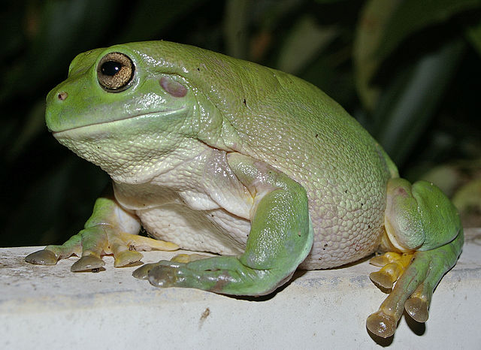  Green Tree Frog CC-BY Bidgee (2007) | Bleating Tree Frog (Litoria dentata)  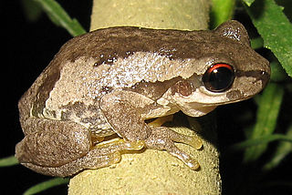  The Bleating Tree Frog BY-SA LiquidGhoul (2006)
Eastern Dwarf Tree Frog  (Litoria fallax)  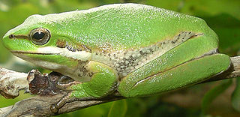  Litoria Fallax CC LiquidGhoul (2005) | Leaf Green Tree Frog  (Litoria phyllochroa)  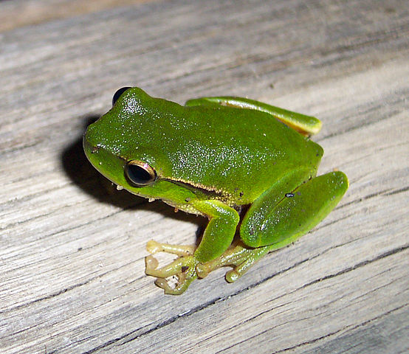  Leaf Green Tree Frog BY-SA Tnarg 12345 (2006) | Peron's Tree Frog  (Litoria peronii)  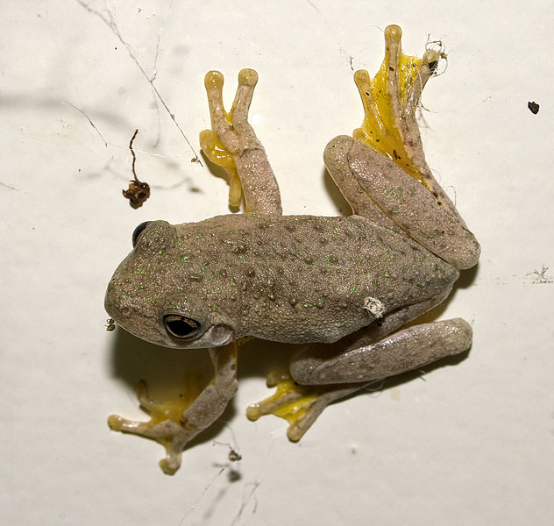  Peron’s Tree Frog BY-SA Bidgee (2011)
Great Barred Frog (Mixophyes fasciolatus)  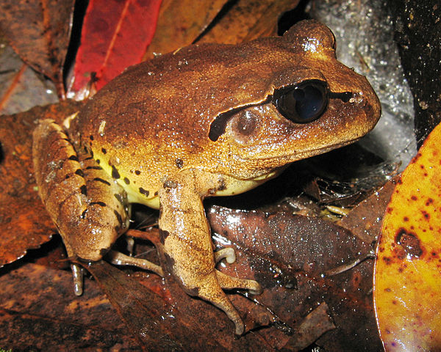  A male Great Barred Frog CC LiquidGhoul (2006) | Red-backed Toadlet  (Pseudophryne coriacea)  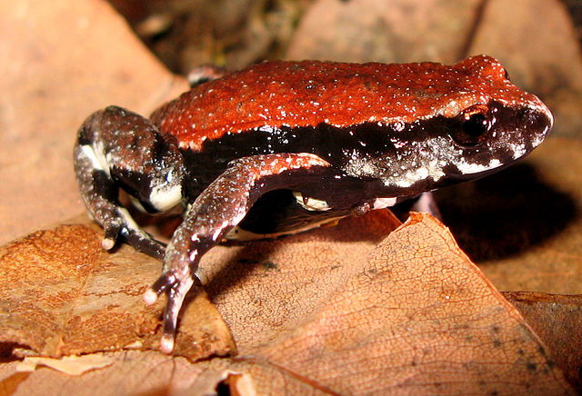  Red Backed Toadlet BY-SA LiquidGhoul (2008) | Striped Marsh Frog (Limnodynastes peronii)  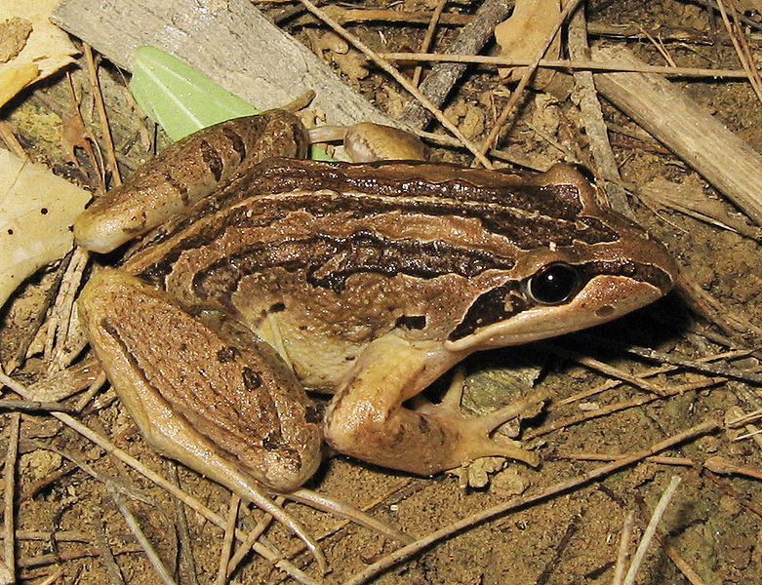  Striped Marsh Frog BY-SA LiquidGhoul (2006)
Eastern Banjo Frog  (Limnodynastes dumerilii)  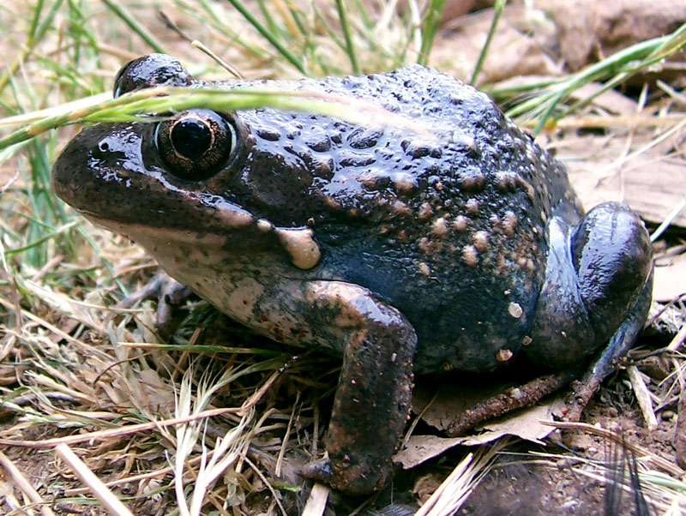  Eastern Banjo Frog BY_SA Fir0002 (2005) | Sphagnum Frog  (Philoria sphagnicola)  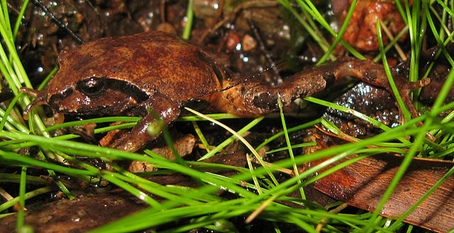  A Sphagnum or Bog Frog BY-SA LiquidGhoul (2008) | Tusked Frog  (Adelotus brevis)  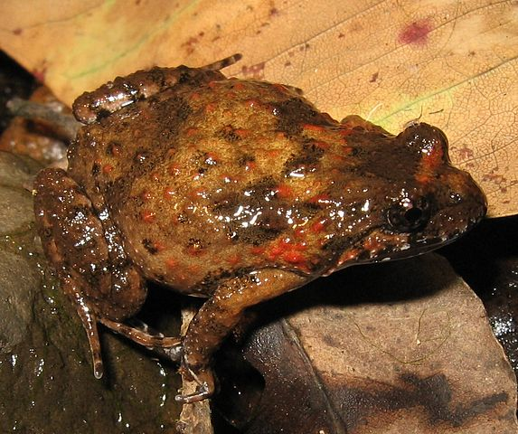  Female Tusked Frog BY-SA LiquidGhoul (2006)

Vivian Harris CC BY_NC

